**OBSERVATIONAL ROUND – 3RD NIGHT**

This exam consist of 3 tables and 4 full sky charts in Equatorial coordinates, showing the sky for the four seasons. On those charts different objects are marked in different colours: constellations are noted in blue capital letters; stars are noted in red arabic algarisms and deep sky objects are noted in green small caps. The charts contain 20 stars, 20 constelations and 10 deep sky objects to be marked on tables I, II and III. Your task is to correctly address the objects in the tables.

Table I - LIST OF CONSTELLATIONS

(A, B, C, D, F, G, H, I, K, L, M, N, O, P, R, S, T, V, X, Z)

|  |  |  |  |
| --- | --- | --- | --- |
| **( ) Andromeda** | **( ) Antlia** | **( ) Apus** | **( ) Aquarius** |
| **( ) Aquila** | **( ) Ara** | **( ) Aries** | **( ) Auriga** |
| **( ) Bootes** | **( ) Caelum** | **( ) Camelopardus** | **( ) Cancer** |
| **( ) Canes Venatici** | **( ) Canis Major** | **( ) Canis Minor** | **( ) Capricornus** |
| **( ) Carina** | **( ) Cassiopeia** | **( ) Centaurus** | **( ) Cepheus** |
| **( ) Cetus** | **( ) Chamaeleon** | **( ) Circinus** | **( ) Columba** |
| **( ) Coma Berenices** | **( ) Corona Australis** | **( ) Corona Borealis** | **( ) Corvus** |
| **( ) Crater** | **( ) Crux** | **( ) Cygnus** | **( ) Delphinus** |
| **( ) Dorado** | **( ) Draco** | **( ) Equuleus** | **( ) Eridano** |
| **( ) Fornax** | **( ) Gemini** | **( ) Grus** | **( ) Hercules** |
| **( ) Horologium** | **( ) Hydra** | **( ) Hydrus** | **( ) Indus** |
| **( )** [**Lacerta**](http://www.anos-luz.pro.br/consthtml/hyd.html#3) | **( ) Leo** | **( )** [**Leo Minor**](http://www.anos-luz.pro.br/consthtml/hyd.html#5) | **( ) Lepus** |
| **( ) Libra** | **( ) Lupus** | **( ) Lynx** | **( ) Lyra** |
| **( ) Mensa** | **( )Microscopium** | **( ) Monoceros** | **( ) Musca** |
| **( ) Norma** | **( ) Octans** | **( ) Ophiuchus** | **( ) Orion** |
| **( ) Pavo** | **( ) Pegasus** | **( ) Perseus** | **( ) Phoenix** |
| **( ) Pictor** | **( ) Pisces** | **( ) Piscis Austrinus** | **( ) Puppis** |
| **( ) Pyxis** | **( ) Reticulum** | **( ) Sagitta** | **( ) Sagitarius** |
| **( ) Scorpius** | **( ) Sculptor** | **( ) Scutum** | **( ) Serpens** |
| **( ) Sextans** | **( ) Taurus** | **( ) Telescopium** | **( ) Triangulum** |
| **( ) Triangulum Australis** | **( ) Tucana** | **( ) Ursa Major** | **( ) Ursa Minor** |
| **( ) Vela** | **( ) Virgo** | **( ) Volans** | **( ) Vulpecula** |

Table II - LIST OF STARS

(1, 2, 3, 4, 5, 6, 7, 8, 9, 10, 11, 12, 13, 14, 15, 16, 17, 18, 19, 20)

|  |  |  |  |
| --- | --- | --- | --- |
| **( ) Achernar** | **( ) Atria** | **( ) Fomalhaut** | **( ) Pollux** |
| **( ) Acrux** | **( ) Avior** | **( ) Gacrux** | **( ) Procion** |
| **( ) Adhara** |  | **( ) Gamma Velorum** | **( ) Regulus** |
| **( ) Al Na'ir** | **( ) Bellatrix** | **( ) Hadar** | **( ) Rigel** |
| **( ) Aldebaran** | **( ) Betelgeuse** | **( ) Hamal** | **( ) Rigil Kentaurus** |
| **( ) Alhena** | **( ) Canopus** | **( ) Kaus Australis** | **( ) Sargas** |
| **( ) Alioth** | **( ) Capella** | **( ) Menkaliman** | **( ) Shaula** |
| **( ) Alkaid** | **( ) Castor** | **( ) Miaplacidus** | **( ) Sirius** |
| **( ) Alnilan** | **( ) Delta Velorum** | **( ) Mirfak** | **( ) Spica** |
| **( ) Alphard** | **( ) Deneb** | **( ) Mirzam** | **( ) Vega** |
| **( ) Altair** | **( ) Deneb Kaitos** | **( ) Nunki** | **( ) Wezen** |
| **( ) Antares** | **( ) Dubhe** | **( ) Peacock** | **( ) Saiph** |
| **( ) Arcturus** | **( ) El Nath** | **( ) Polaris** |  |

Table III - LIST OF DEEP SKY OBJECTS

a, b, c, d, e, f, g, h, m, r

|  |  |  |
| --- | --- | --- |
| **( ) Andromeda Galaxy** | **( ) Eta Carinae Nebula** | **( ) Perseus Double Cluster** |
| **( ) Centaurus A** | **( ) Great Rift** | **( ) Pleiades** |
| **( ) Coal Sack** | **( ) Helix Nebula** | **( ) Praesepe Cluster** |
| **( ) Cone Nebula** | **( ) Hercules Globular Cluster** | **( ) Ring Nebula** |
| **( ) Crab Nebula** | **( ) Large Magellanic Cloud** | **( ) Sagittarius A** |
| **( ) Dumbell Nebula** | **( ) Omega Centauri Cluster** | **( ) Small Magellanic Cloud** |
| **( ) Eagle Nebula** | **( ) Orion Nebula** | **( ) Trifid Nebula** |

**Chart 1**

IOAA Observational Exam 2012-3rd_try-charts

**Chart 2**

**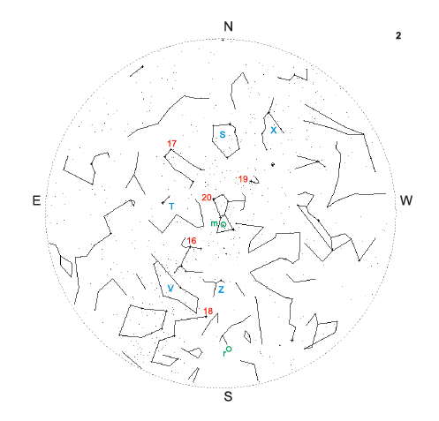**

**Chart 3**

**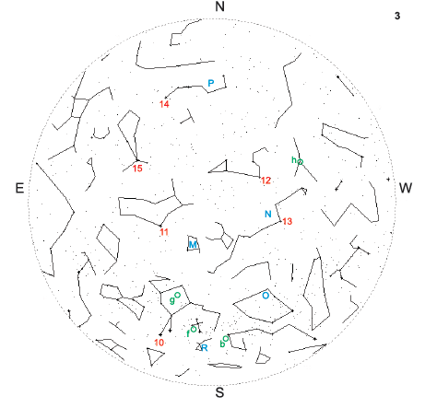**

**Chart 4**

**